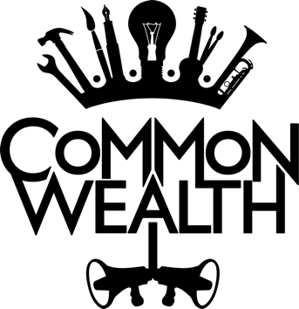



 

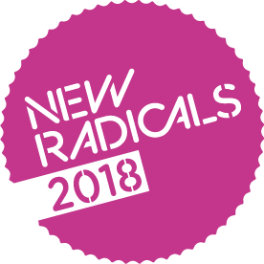 

**Common Wealth** are looking for up to three new trustees to join our board to help us achieve our mission!

We are looking for individuals who might have the following experiences; and welcome applications from everyone and particularly encourage applicants who are usually under-represented[1] in the theatre industry.

* Fundraising
* Strategic Leadership
* Media and Communications or PR
* Arts
* Social Change

**A passion for the arts and social change is essential.**

This role is voluntary with a commitment to attend four board meetings a year, an annual away day and performances and events. Appointments are for an initial term of three years with the option of an additional three years.

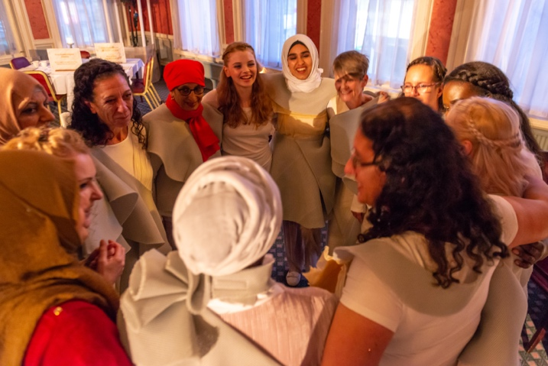

**ABOUT Common Wealth**

**“Common Wealth will be changing the way we look at the world for years to come”**

**(John McGrath, Manchester International Festival)**

Common Wealth make site-specific theatre events that encompass electronic sound, new writing, visual design and verbatim. Our work is political and contemporary. We make work that is relevant and addresses concerns of our times. Common Wealth’s work is based in the here and now, and feels, looks and sounds like contemporary Britain.

Our values are expressed in our name ‘Common Wealth’ which points to the wealth of experiences, stories and imagination in places and communities often dismissed as ‘poor’ or ‘in need’ of cultural development. In being common and in being in common with our audiences, we create riches to share. Our work is rooted in the communities where productions are made and it has international relevance; we have seen the universal nature of the stories we present connect with people across the world. To date we have worked with, among others, steelworkers, Muslim female boxers, survivors of domestic abuse, people experiencing long-term unemployment and young people from around the world. Common Wealth sees its work as a campaign that contributes to making change possible. We believe that each production has a series of ripples from it and different ways of connecting and having impact on people’s lives.

Common Wealth was founded by co-artistic directors Rhiannon White and Evie Manning in 2011 created from a DIY spirit - creating theatre in empty buildings, with lots of people and with social change at its heart. In 2018 we became a National Portfolio organization with Arts Council England, which saw a significant step change for the company - this was followed by Common Wealth receiving the Paul Hamlyn Breakthrough Fund. The combination of these funds has supported and enabled the organisation to grow, work over longer time frames, provide employment opportunities and build capacity and resilience. For more information about Common Wealth visit our website – [www.commonwealththeatre.co.uk](http://www.commonwealththeatre.co.uk)

**Key Facts about Common Wealth**

* Common Wealth is an Arts Council England National Portfolio organisation (2018 –2022) and in receipt of grants from a number of charitable trusts and foundations
* We are a multi-award-winning company working across England and Wales, we produce one large scale production every year with ambitions to tour nationally and internationally.
* We are part of and support Speakers Corner a social space run by young girls and women.

**Common Wealth’s Board**

The Common Wealth Board meets quarterly, in Bradford or Cardiff. We pay travel expenses and accommodation expenses when these are required. Board members are also expected to be involved outside Board meetings – this might be on a small task group, or writing short papers, or offering advice on issues facing the company – within the understanding that Board members are busy people and need to fit this additional work in with their own personal and professional lives.

**ROLE OF TRUSTEES**

Trustees are responsible for overseeing the management, finances and governance of Common Wealth ensuring that that its activities are planned and carried out to meet its charitable aims.

**Main duties of an individual Board member**

To Attend meetings of board members, scrutinise board papers, participate in discussions, and provide advice and guidance on new initiatives.

**Providing strategic leadership**

* Consider the organisation as a whole, whether as a member of the board, or within any of its committees, sub-committees, groups etc.
* Reflect the organisation’s vision and principles, strategy and major policies at all times.
* Contribute specific skills, interests and contacts and support the organisation in fundraising activities.

**Ensuring policies and practices are in keeping with aims**

* Follow the policies of the organisation at all times, particularly when exercising the functions of the board members, or any of its committees, sub-committees and groups
* Reflect the board members’ concerns on all its committees, sub-committees and groups.

**Ensuring best practice**

* Ensure the effective and efficient administration of the organisation, and its financial health.
* Take part in Board training and development activities
* Be an active member of the board in exercising its responsibilities and functions, including attending performances, workshops and events from time to time

**HOW TO APPLY**

To apply please send a letter of interest, outlining your experience and why you wish to become a Trustee of Common Wealth. Please send to tracy@commonwealththeatre.co.uk

Deadline for receipt of applications is 22nd July at 5pm.

If you would like any further information on this role please contact tracy@commonwealththeatre.co.uk

1. ‘Oakley (2013) reports that it cannot be overstated how little success there has been in terms of tackling under-representation in terms of gender, ethnicity or social class in the cultural industries, and most of the data show the problem to be getting worse rather than improving.’ As referenced in Arts Council England’s Equality and Diversity Evidence Review.