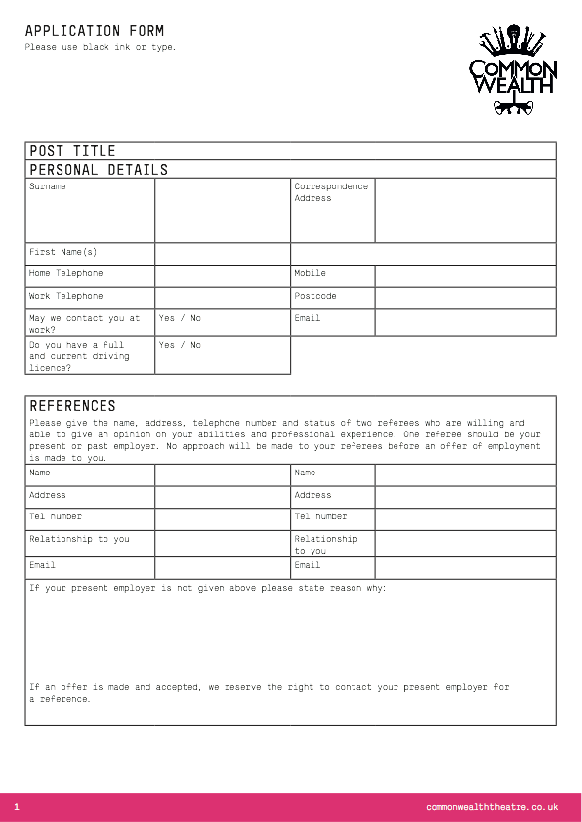

Type to enter text

Type to enter text

Type to enter text

Type to enter text

Type to enter text

Type to enter text

Type to enter text

Type to enter text

Type to enter text

Type to enter text

Type to enter text

Type to enter text

Type to enter text

Type to enter text

Type to enter text

Type to enter text

Type to enter text

Type to enter text

Type to enter text

Type to enter text

Type to enter text

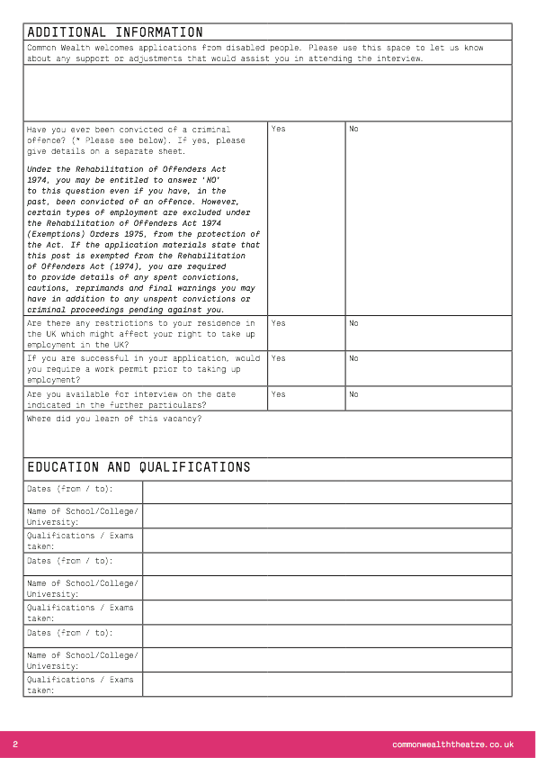

Type to enter text

Type to enter text

Type to enter text

Type to enter text

Type to enter text

Type to enter text

Type to enter text

Type to enter text

Type to enter text

Type to enter text

Type to enter text

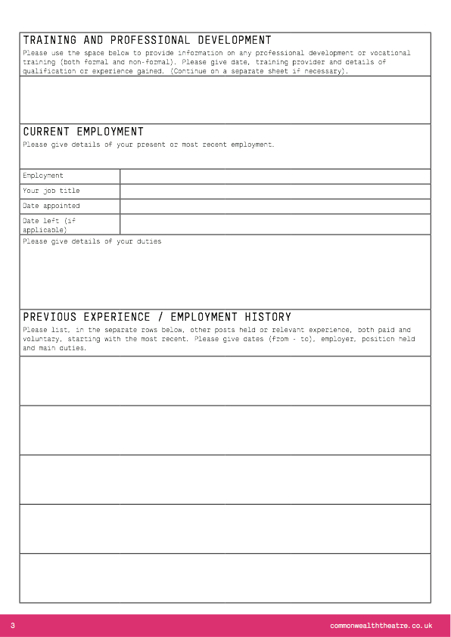

Type to enter text

Type to enter text

Type to enter text

Type to enter text

Type to enter text

Type to enter text

Type to enter text

Type to enter text

Type to enter text

Type to enter text

Type to enter text

Type to enter text

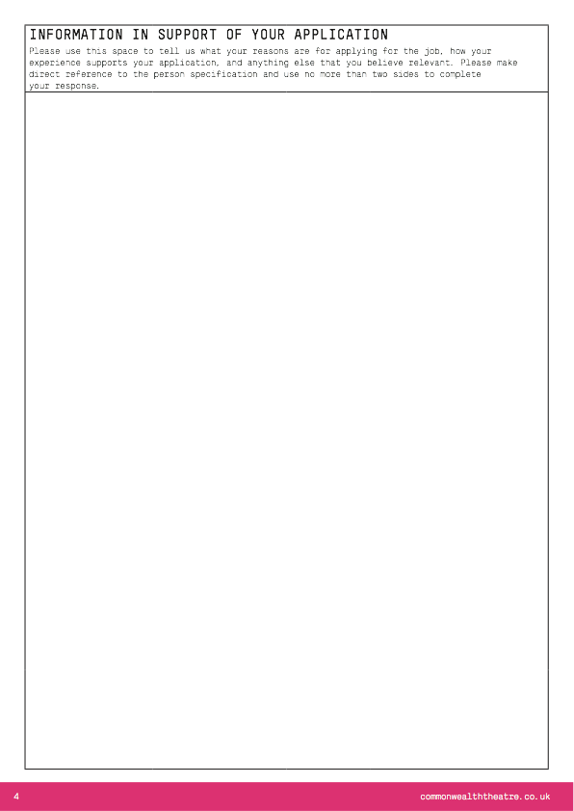

Type to enter text



Type to enter text

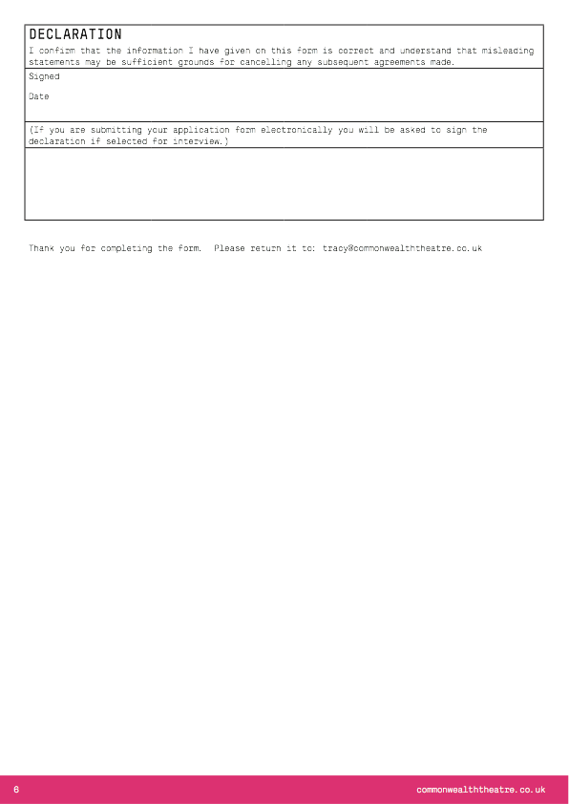

Type to enter text

Type to enter text

Type to enter text