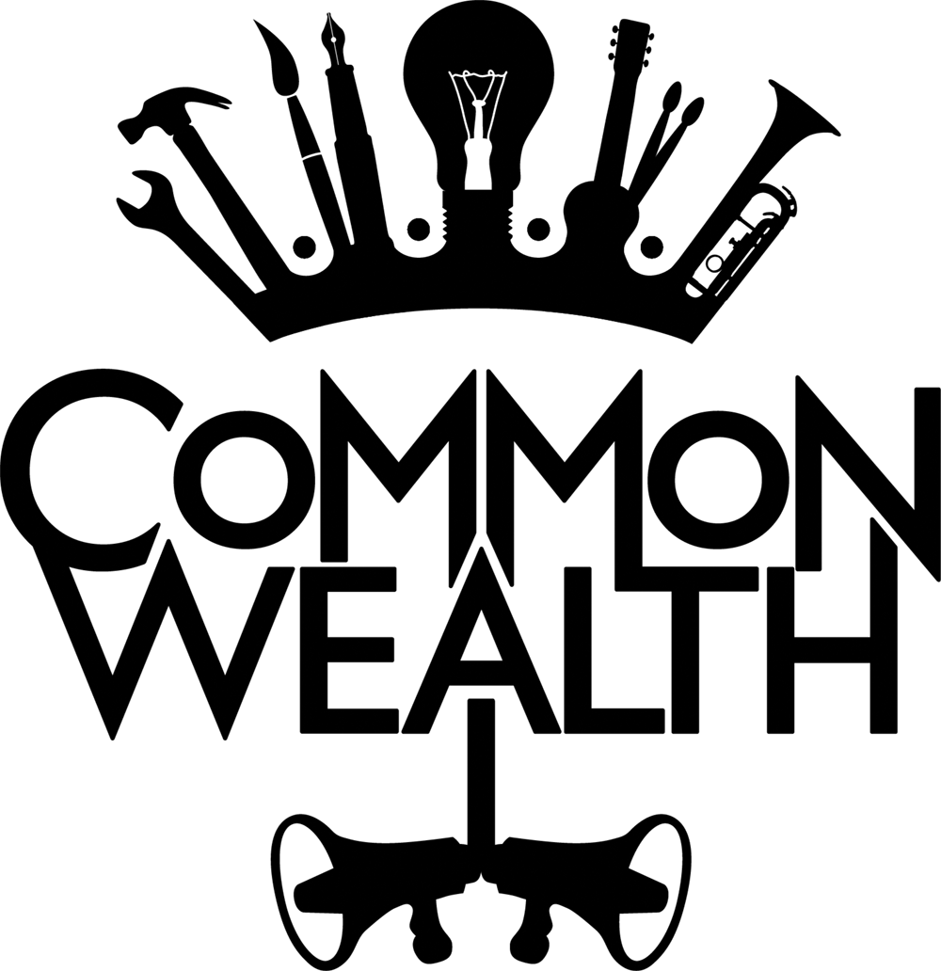

CARDIFF ARTISTIC DIRECTOR JOB PACK

Job Title: Cardiff Artistic Director, Maternity Cover
Responsible to: Jenny Hughes, Vice Chair

Salary: £31,200 per annum pro rata.

Contract: This is a part-time position, to cover a 9 month period of maternity leave. Provisional contract dates at the time of advertising are from 14 December 2020 to 17 September 2021. To be reviewed three months, with potential of increasing hours if required.

Hours of work: 3 days (21 hours) per week, to fit in with the wider team. General office hours are 10am - 6pm, Monday to Friday with one unpaid hour for lunch. Occasional evening and weekend work will be required.

Annual Leave: 25 days annual leave plus bank holidays on a pro-rata basis

Pension: Employees are automatically enrolled onto Common Wealth’s Workplace Pension (NEST) after completion of a three- month probationary period. They can opt out if preferred.

Place of work: Common Wealth are based in Bradford, England and Cardiff, Wales. This role will be based in Cardiff. For this role the place of work is Llanrumney Hall, Ball Road, Llanrumney, Cardiff, Cf3 4JJ. Currently the Common Wealth team are working from home with occasional in-person meetings.

References: All offers of employment subject to receipt of two satisfactory references. We will seek your permission before making direct contact with any referees.

We are committed to widening access and promoting Equality and Diversity among our staff. We are particularly interested in hearing from people who are under-represented in the arts sector due to their social class, ethnic background or disability.

ABOUT COMMON WEALTH THEATRE

“The Company who burst open our consciousness” Lyn Gardner, The Guardian

Common Wealth are an award-winning site-specific theatre company making theatre that encompasses electronic sound, new writing, visual design and verbatim. Our work is political and contemporary. Common Wealth are based in Bradford and Cardiff and make work that tours across the UK and internationally. Recent productions include I Have Met the Enemy (and the enemy is us) (Northern Stage), Radical Acts, We’re Still Here (National Theatre Wales), No Guts, No Heart, No Glory, (Scotsman Fringe First Award / Live from TVC on BBC4), Our Glass House, (Amnesty Freedom of Expression Award.)
Our values are expressed in our name ‘Common Wealth’ which points to the wealth of experiences, stories and imagination in places and communities often dismissed as ‘poor’ or ‘in need’ of cultural development. In being common and in being in common with our audiences, we create riches to share. Our work is rooted in the communities where productions are made and it has international relevance; we have seen the universal nature of the stories we present connect with people across the world. Common Wealth sees its work as a campaign that contributes to making change possible. We believe that each production has a series of ripples from it and different ways of connecting and having impact on people’s lives.

Common Wealth is led by Co-Artistic Directors Rhiannon White and Evie Manning who both live and work from their hometowns, Cardiff and Bradford respectively. Operating from these two locations we run a programme of activity that spans large-scale site-specific touring productions, ground-breaking participatory work, artist development, Speakers Corner (a social space led by women & girls) and the programming of co-created work as part of the Moving Roots Touring Network.
“Common Wealth will be changing the way we look at the world for years to come” John McGrath, Artistic Director, Manchester International Festival
Artistic Director Cardiff (Maternity Cover)
Common Wealth is looking for an exceptional and ambitious artistic director to cover a period of maternity leave. As Rhiannon White, Co-Artistic Director based in Cardiff will be stepping back for maternity, this role will cover aspects of her role and responsibilities.

The successful applicant will work alongside Producer, Camilla Brueton and Community Producer, Chantal Williams to continue to expand the ground-breaking work of the company in Cardiff East.

You will lead the company through its Cardiff creative programme, and help shape and grow the work in line with Common Wealth’s vision and mission.

Highly -motivated and ambitious, you will have a wealth of experience and energy to bring to our small team. You will be passionate about making political theatre for working-class audiences and have a curiosity and desire to work in new ways. You find it easy to communicate verbally and in writing and enjoy building collaborative relationships.

You will be passionate about social change and how the arts can have a role in changing the world.

Responsibilities

ARTISTIC
- Providing inspiration and leadership for Common Wealth Cardiff activities, especially performances and local projects
- Producing/ leading on Common Wealth Cardiff’s programme
- Continuing to build on artistic collaborations and partnerships
- Supporting artists on delivery of process & productions
- Supporting co-created practice on the ground - what it looks like and how it’s delivered in collaboration with the Community Producer & Cardiff East Sounding Board.
- Demystify what theatre is and can be for people – building this into the foundations of all Common Wealth’s delivery.
- Planning and delivery of creative workshops
- Co-creating programming activities with Moving Roots Network and Cardiff East Sounding Board

MANAGEMENT

- Line managing the Cardiff Producer and Community Producer
- Motivating team and other artistic staff as appropriate
- Inspiring collaborators to enable them to achieve their potential, creating new opportunities for their development
- Championing equal opportunity and being an advocate for social change
- Supporting the Producer and Company Manager to oversee and manage Common Wealth’s Cardiff finances.
- Holding weekly meetings with the Cardiff team and attending fortnightly meetings with whole company team.

FUNDRAISING

- Overseeing the delivery of the Cardiff fundraising strategy and plan
- Working with the team to write funding bids

STRATEGY

- Providing strong, inspirational leadership to enable Common Wealth Cardiff to achieve its objectives.
- Attending and providing input to company wide meetings.
- Writing executive report for Common Wealth Cardiff and attending company board meetings

ADVOCACY

- Acting as an ambassador for Common Wealth at all times
- Continuing to build on strong relationships with partners
- Representing the organisation externally at events
- Overseeing Common Wealth Cardiff’s marketing and communications including contributing to social media planning

OTHER

- Promote, and act within, all of Common Wealth’s policies
- Ensuring the culture of Common Wealth is inclusive, collaborative, safe and supportive, as well as artistically bold and ambitious
- Being an active and supportive member of the Common Wealth staff team
- Ensuring Common Wealth operates to the highest ethical standards
- Taking responsibility for the maintenance of good filing/archive systems and database
- Contributing to and participating in monitoring and evaluation

PERSON SPECIFICATION
ESSENTIAL SKILLS, KNOWLEDGE AND EXPERIENCE
- Proven experience in an artistic leadership role within the arts with a demonstrable track record of successful project/production delivery
- An informed interest in the work of Common Wealth and a commitment to our vision and core values
- Experience, knowledge or understanding of co-creation as a artistic practice
- Interest in and experience of delivering site-specific, non-conventional theatre within communities, found spaces, public spaces
- Ability to inspire and motivate staff and creatives, and collaborate with colleagues to identify new opportunities, generate ideas and creatively solve problems
- Ability to work effectively under significant pressure and in the flow of fast-moving events
- Experience of and enthusiasm for leading small teams
- Experience of working with people from a range of backgrounds
- Excellent attention to detail; can demonstrate logical and methodical approach
- Adept with various IT packages and comfortable working with technology
- Strong literacy skills
- A desire for social change

DESIRABLE
- Experience of working with marketing and communications and an understanding of audience development
- Experience of fundraising with a successful track record in the arts, cultural or wider charitable sector
- Welsh language skills

APPLICATION PROCESS

To apply please submit your application, CV and completed equal opportunities form by email with ‘Cardiff AD Maternity Cover’ in the subject line to rhiannon@commonwealththeatre.co.uk by 5pm on Monday 9th November.

Interviews – w/c 16th November 2020
Induction/ start date- 14th December 2020

If you would like to have an informal, confidential conversation about the role, please contact Rhiannon White - rhiannon@commonwealththeatre.co.uk

You can find out more about our Cardiff programme on our website https://commonwealththeatre.co.uk/cardiff/

