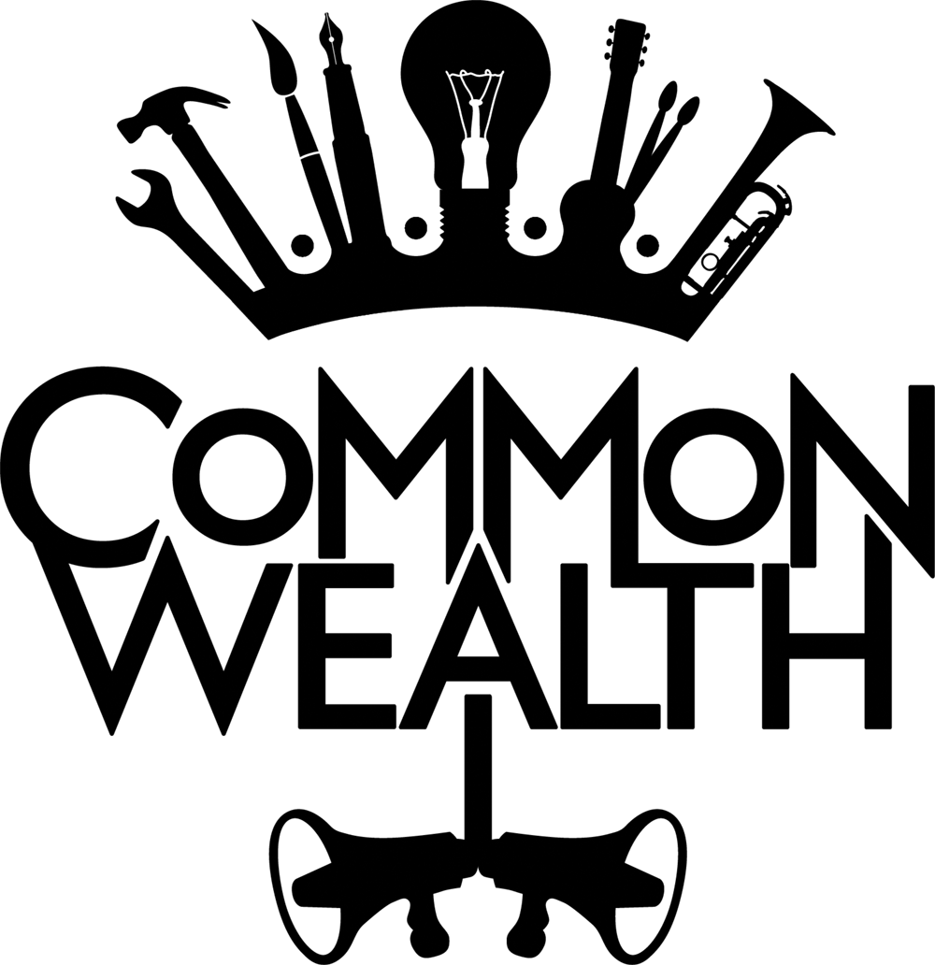

STRATEGIC DIGITAL MARKETING MANAGER INFO PACK

Job Title: Strategic Digital Marketing Manager
Responsible to: Tracy Basu, Company Manager
Fee: £10,500, Freelance
Contract dates: Ideally 16th November 2020 – 9th June 2021 (6 months)
Working Hours: 3 days per week
Location: Could be based anywhere in the UK, with an ability to travel to Bradford and Cardiff on occasion

Deadline: Friday 30th October 2020
Interviews: Friday 6th November 2020 on zoom

Our Work
Common Wealth are an award winning site-specific theatre company making theatre that encompasses electronic sound, new writing, visual design and verbatim. Our work is political and contemporary and responds to the here and now.
Purpose of the role
Common Wealth are based in Bradford and Cardiff and make work that tours across the UK and internationally.

The purpose of this role is both strategic and tactical. Strategic because you’ll be thinking about Common Wealth as a whole company and how we link different projects, past and future work and build our Common Wealth profile. Tactical because you’ll be delivering specific campaigns to build audiences and enable social change which goes way beyond the delivery of our shows themselves.

This role will be about imagining the way that our digital and marketing activity works between two places and embedding process in the team. We see our work as a movement, every project and every show feeling like a campaign, a call to action. We want to work with someone who will inform our approach to sensitive, persuasive, impactful campaigning which results in social change.

We have a body of work to build upon which we would like to amplify. Current projects include Peaceophobia, a site-specific piece in a car park about islamophobia, islam and modified car culture and Us Here Now a photography project exploring the representation and celebration of working class people in Cardiff East.

Who we are looking for
You will be an experienced and effective communicator with a strong knowledge of marketing, digital strategy and comms. You will be creative and visionary and excited about amplifying campaigns and the political nature of our work. You will also be practical and hands on and a good team player, able to respond, delegate and build with the rest of the Common Wealth team.

We welcome applications from everyone and particularly encourage applicants who are usually under-represented in the theatre industry.

Application process
If the person we’re describing sounds like you, we would love to hear from you. Please email your CV, an example of a past campaign you’re most proud of and a statement about why you’re interested to info@commonwealththeatre.co.uk with the title ‘Strategic Digital Marketing Manager ’ in the subject line.

Job Description
Since this is a new post, we imagine the scope/detail of the role will develop as we work together. In the first instance however, the role will include the following:
- To support with all aspects of marketing, communications and digital across the company in Bradford and Cardiff
- Create and implement a digital marketing strategy for the company
- Lead on content creation ideas and support others across the team to implement this
- Lead on writing copy for marketing material in print media and the website
- Manage a marketing budget and payment of advertising, digital products, graphic design, etc
- Support the promotion of a livestream of the show Peaceophobia
- Work closely with a Welsh translator to ensure relevant digital and print communications are produced bi-lingually
- Update and manage the Common Wealth website
- Devise ideas and deliver ways to amplify past works and build partnerships across the UK
- Manage Common Wealth social media channels (with support from the team)
- Support the staff team with our audience development plan
- Ensure branding is consistent across the company on all external and internal platforms
- Ensure all Common Wealth communications are fully accessible

Person Specification

Qualities and Attributes
- A desire for social change
- An informed interest in the work of Common Wealth and a commitment to our vision and core values
- A sensitivity to communicating the complexities of class, race and religion
- A commitment to producing accessible communications that meet or exceed current access standards
- A strong visual background and an eye for detail
- Excellent communication skills and the ability to develop relationships
- Ability to work independently effectively under pressure and to tight deadlines

Skills and Experience
- Significant experience as a communications/media professional, with a track record of developing, leading and managing creative audience focused communications campaigns
- Demonstrable experience of operational brand development
- Excellent creative copywriting and storytelling skills
- Experience in developing creative concepts, commissioning and/or producing content
- Experience of press and media planning, writing press releases, as well as securing press for key events
- Track record of developing online content through website,
social media, digital marketing, & SEO activity and culture – cross-sector / and political, as well as grassroots levels
- Up to date knowledge of GDPR (data protection), and its implications for communications and marketing campaigns
- Experience of budget management
- Some experience of managing digital projects, live streaming and 360 filming would be an advantage

