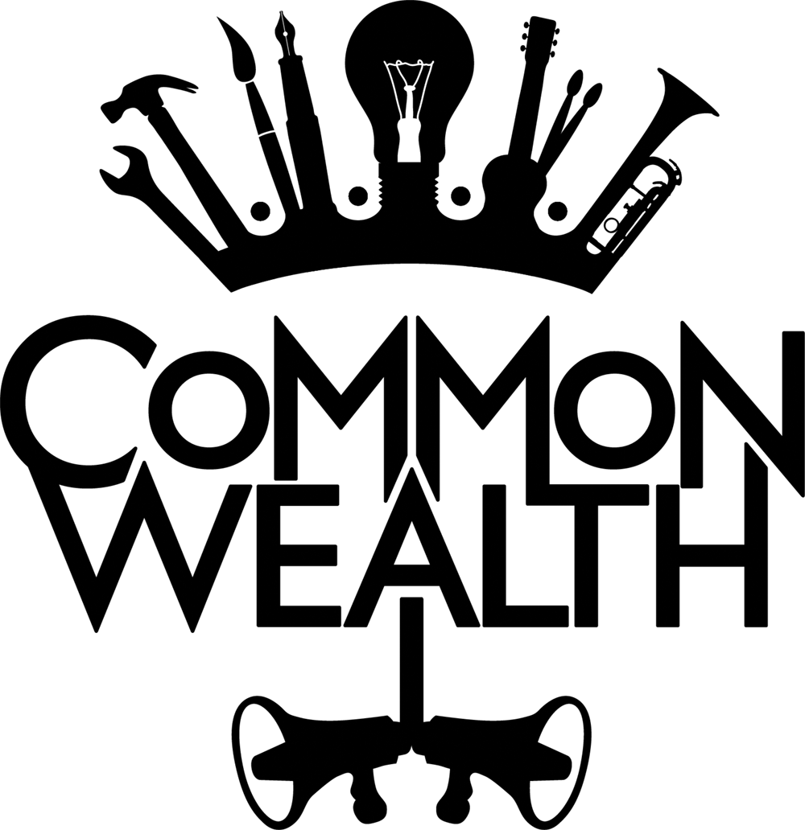

THERE IS AN ALTERNATIVE
IDEA SUBMISSION FORM

We want the application process to be as straight-forward as possible, please answer each question with a maximum of two sentences if you can.

ABOUT YOUR IDEA

Main Contact
Name and email
Artform
E.g. video, visual art, poetry, performance, song, installation, audio piece, etc
Subject you would like to explore / Alternative you would like to present

Why this subject? Why is this subject close to you?

Who would you like to co-create with?
(Individual or group)
(Are they confirmed or unconfirmed?)
Why this Co-Creator?

Where do you consider yourself in your career?  (Please delete as appropriate) | Young artist  Early Career  Established Artist
What’s your connection to Bradford?
What kind of exhibition space would you need?
(Wall, floor, screen, etc)
Do you have any access needs?
Anything else you’d like to add?
(you don't have to!)

Along with this form, please attach a link to your work and/or 3 images of existing work. If the idea is an existing idea, then one of these attachments could expand on your idea in more detail.

CONTACT

Please return this form to Shazia Bibi shazia@commonwealththeatre.co.uk by Tuesday 25th May 2021 at 12pm

