Off The Curriculum: Group bookings
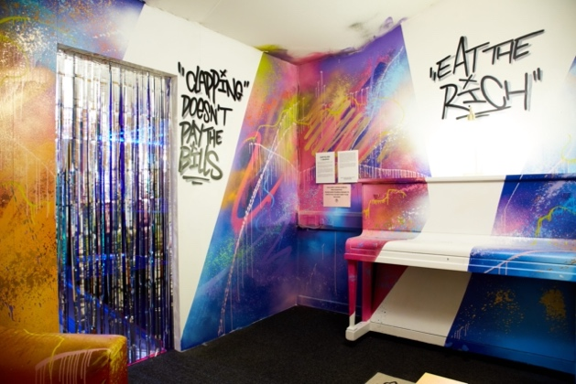
Background
Off the Curriculum is a giant immersive exhibition which launched with a festival in March 2023. All the rooms in our building have been trarsformed by children and young people. Each installation is a pairing of a subject not taught at school with an art form not taught at school. Time travel & jewellery, capitalism & graffiti, self-care & pottery and much more.
The project asks: How can school be different? Should kids lead the curriculum? What do we learn and why?
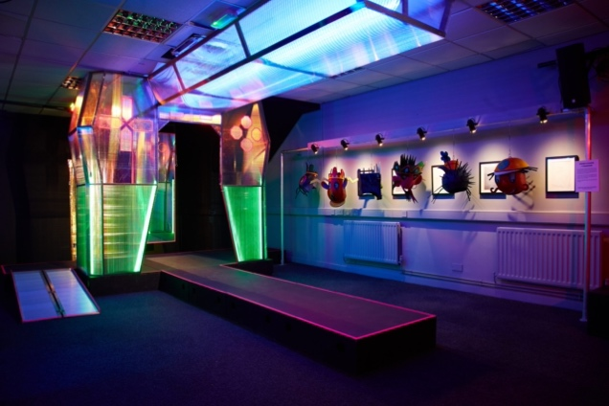
Group Bookings
Not everyone could come to the festival, so we’re inviting youth groups to visit this Spring.

  - Explore 14 installations.
  - Meet some of the young people leading the project.
  - Take part in a creative workshop to design your own room.
  - Debate ideas on how the education system could be different.

Where: Common Space, 1-3 John Street, Bradford, BD1 3JT

Times: Allow for 1.5 hours with us

When: Slots available 11am – 6pm on these dates.
May | June
Thurs 4th | Fri 2nd
Fri 5th | Tues 6th
Tues 9th | Wed 7th
Wed 10th | Thurs 8th
Thurs 11th | Fri 9th
Fri 12th | Tues 13th
Mon 22nd | Wed 14th
Tues 23rd | Thurs 15th
Fri 26th

If you would like to book a visit, email may@commonwealththeatre.co.uk with suggested dates/ times, group numbers and ages. We will book on a first come first served basis.

